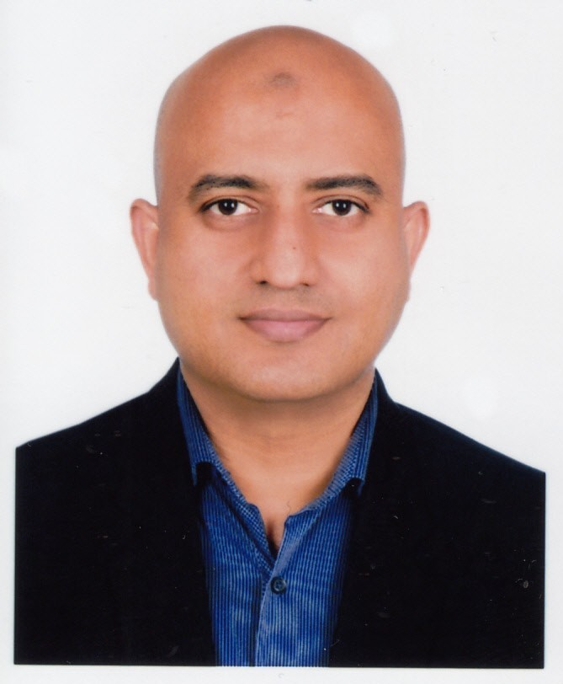
S. M. Rumman Wahid

Flat-D3, 3rd Floor, Heaven City-9,

197 East Kazipara, Mirpur, Dhaka-1216.

Phone: 01715134161; Email: wahid953@gmail.com

Education Asian University of Bangladesh, School of Business

Bachelor of Business Administration (BBA) November 2006

Major: Finance, CGPA: 3.22 (4.00)

Sylhet Cadet College

Higher Secondary Certificate (HSC) October 2000

Group: Science, Result: First Division

Activities and Societies: Sylhet Cadet College Band Team Bassist in Inter Cadet College Literature & Music Meet-1999 held at Pabna Cadet College.

Sylhet Cadet College

Secondary School Certificate (SSC) August 1998

Group: Science, Result: First Division

Activities and Societies: Awarded "Best footballer of Junior Group” in Inter-House Football Tournament-1997.

Experience ABC Radio FM 89.2 (Sister Concern of Prothom Alo), Dhaka, Bangladesh.
Post: Assistant Manager, HR January 2018 – Present
- Managed a broad range of HR Functions including but not limited to payroll, benefit plan, HRIS, ERP, personal file, HR policy, hiring, staff training and development etc.
- Served as the HR Business Partner to the Line Managers and Senior Management.
- KPI and goal setting.
- Processed all new hire, exit and benefits paperwork ensuring 100% compliance with various laws and regulatory mandates and serving as primary contact person answering management/ staff questions.
- Jointly designing and implementing company’s newest HRIS project.
- Coordinate with Senior Management to plan, organize, implement and monitor all organizational development related activities.

ABC Radio FM 89.2 (Sister Concern of Prothom Alo), Dhaka, Bangladesh.
Post: Senior Executive, HR January 2014 – December 2017
- Successfully implemented HR Policy which ensured proper guideline and provided Managers with critical tools to enhance efficiency.
- Drafting Job Descriptions.
- Doing Training Need Assessment (TNA), arranging Internal and external training.
- Established Performance appraisal system of the company.
- Administered Payroll, compensation, OT (Over time) payment and HR budgeting.
- Compliance and oversee changes in Bangladesh Labour Law 2006.

ABC Radio FM 89.2 (Sister Concern of Prothom Alo), Dhaka, Bangladesh.
Post: HR Executive January 2011 – December 2013
- Record keeping of employees’ activities, maintaining individual service file.
- Maintaining attendance, leave and absenteeism.
- Management of HR budgeting.
- Dealing employer branding.

ABC Radio FM 89.2 (Sister Concern of Prothom Alo), Dhaka, Bangladesh.
Post: Executive, Sales & Marketing May 2010 – December 2010
- Client (Ad Agency) peach.
- Proposal sending to clients.
- Attending clients meeting in the Ad Agency.

ABC Radio FM 89.2 (Sister Concern of Prothom Alo), Dhaka, Bangladesh.
Post: Executive, Admin. October 2009 – April 2010
- Supporting Administration In-charge in all administrative works as well as coordinating in certifying of vehicle daily log and fuel consumption, update and maintenance of vehicle history report.
- Schedule company transport services for an efficient pick & drop service.
- Managing the Meeting Minutes of COO.

NMCI Bangladesh Limited, Dhaka, Bangladesh.
Post: Management Trainee, Pre Shipment Inspection (PSI) January 2008 – February 2008
- Daily attendance reporting of Dhaka office.
- To assist the PSI (Pre-Shipment Inspection) operation team.
- Taking a global reference number electronically from the head office in New Jersey, USA.

Skills & Expertise
- HR Strategy • HR Policies • HR Transformation • Employee Relations • Performance Management • Event Management • Employer Branding • Talent Acquisition • Talent Management • HR Business Partnership • Compensation & Benefits Design • Training & Development • Organizational Development • Manpower planning • Team building • Change Management • Leadership Development • MS Office • MS Excel • Power Point • Sage ERP ACCPAC • HRIS

Additional • I’m a member of OCAS (Old Cadets Association of Sylhet) since October 2000.
- Participated on BSHRM 4th International HR Conference 2015 held on 28 February 2015 in Bangabandhu International Conference Center, Dhaka.
- I’ve participated in a training on 21st Century HR Academy jointly conducted by Chakri.com and HR Kites in November 2013.
- I’ve participated in a training on Bangladesh Labour Law 2006 conducted by Chakri.com in January 2013.
- I’ve participated in a workshop on Collective Management Organization organized by Copyright Office Bangladesh & WIPO (World Intellectual Property Organization) Asia Chapter in June 2011.
- I have an IELTS band score of 5.0 dated November 2007 exam taken by British Council.

